Dear families,
We’re excited to introduce LENA Grow, a professional development program to help our teachers grow and support your child’s learning!

What is LENA Grow?
LENA Grow helps teachers talk more with children. Interactions are very important for your child’s development and kindergarten readiness.
How it works:
 |  | 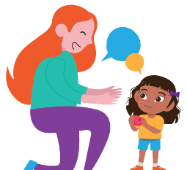
Children wear a small safe device once a week to capture classroom interactions. | Software counts words and conversations. | Teachers use this information to increase interactions and improve learning.
LENA is safe, secure, and private:

Learn more!
info.lena.org/families
- LENA has been trusted by over 5,000 teachers and 100,000 children.
- LENA does not understand words and cannot play back. No one can hear what was said or how it was said.
- Recorded sounds are automatically deleted and never saved.
- Data is shared only with people helping your child learn, such as teachers and coaches.

Thank you for participating!
If you have more questions about LENA Grow, contact: <insert org contact name, email, phone #>
Important: In three days, your child will be automatically included in LENA Grow.
If you DO NOT want your child to participate in the LENA Grow program please check the box below, sign, and return within three days.
❐ No, my child ___________________________ cannot participate in the LENA Grow program. I understand other children in the room will still participate.
Parent’s Signature _____________________________________ Date _______________

