 Site Agreement

Welcome to LENA Grow!

We’re excited to partner with you and the LENA Grow program.
You play a pivotal role in LENA Grow’s success. This agreement outlines important program details to set you up for success. Please review carefully.
Discuss any questions with your LENA Grow coach.

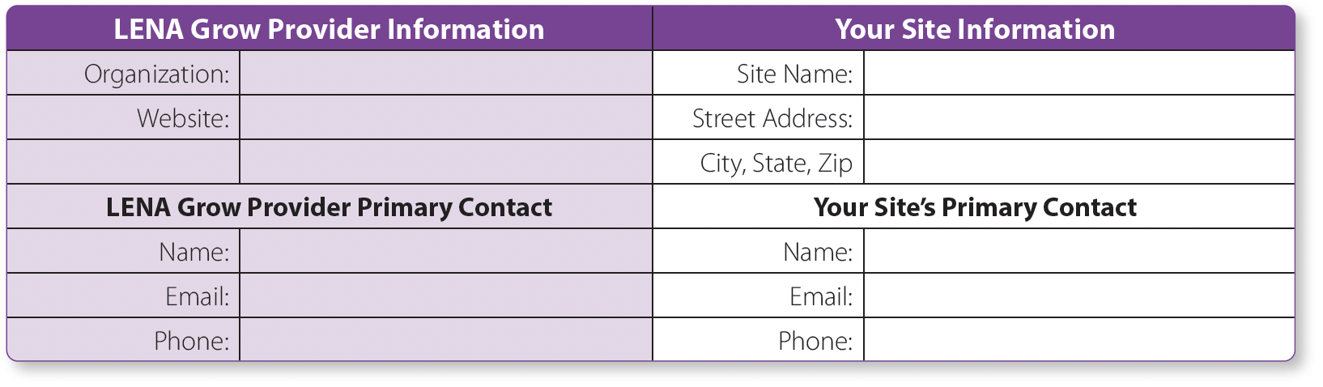

Site Commitments
Site leadership sets the tone for how LENA Grow will be embraced and embedded in your organization. Specifically, you will help:
- Foster enthusiasm
- Support teachers
- Engage families
- Collaborate with coaches

Getting Started
- Identify a main contact to communicate with the LENA Provider and ensure on-site tasks are completed.
- Work with the LENA Provider to decide which classrooms will participate, a target timeline for each one, and who will coach.
- Provide coach with program information (including but not limited to): classroom names, teacher names/emails, and availability for coaching sessions.
- Site leadership attends Orientation with teachers and supports them in the family consent collection process.
- Provide coach with enrollment information for each classroom: child first names, last names, and dates of birth.
- Receive and distribute LENA Room kits (one box per classroom) for use during the LENA Grow Sequence.

LENA Grow Site Agreement

Preparing Materials
  - Launder LENA vests and return to classroom before next LENA Day.
  - Print color copies of LENA reports (reports may be emailed by coaches in addition to printing).
  - Print (or share electronically) weekly family engagement resources for teachers to share with families.

During the Sequence
- Follow Sequence Schedule agreed upon with LENA Provider. Ensure teacher Orientation, LENA Days, and coaching sessions occur as planned, and notify coach in the event a teacher is unavailable.
- Ensure participating teachers have class coverage to attend the following sessions, ideally outside of the classroom (either in-person or virtually):
  - Teacher Orientation (1 hour)
  - Session 1 (1 hour)
  - Sessions 2-4 (30 minutes each)
  - Session 5 (1 hour)

Wrapping up
- Return LENA technology (dock, devices) at the end of the LENA Grow sequence. (Pre-paid shipping labels will be provided.)
- Celebrate teacher accomplishments!

LENA Provider signature

Date
Site primary contact signature

Date


For more information, contact:
303-441-9085 | info@lena.org | www.LENA.org


@LENAEarlyTalk v.20240109

